URL: https://adityabirlahospital.com/blogs/top-5-pre-wedding-skin-treatments-recommended-by-dermatologists
Meta Title: Top 5 Pre-Wedding Skin Treatments | Aditya Birla Memorial Hospital
Meta Description: Learn about the best pre-bridal skin treatments, timelines, dermatologist-approved routines, and tips for glowing, healthy skin before your wedding.
H1: Top 5 Pre-Wedding Skin Treatments Recommended by Dermatologists
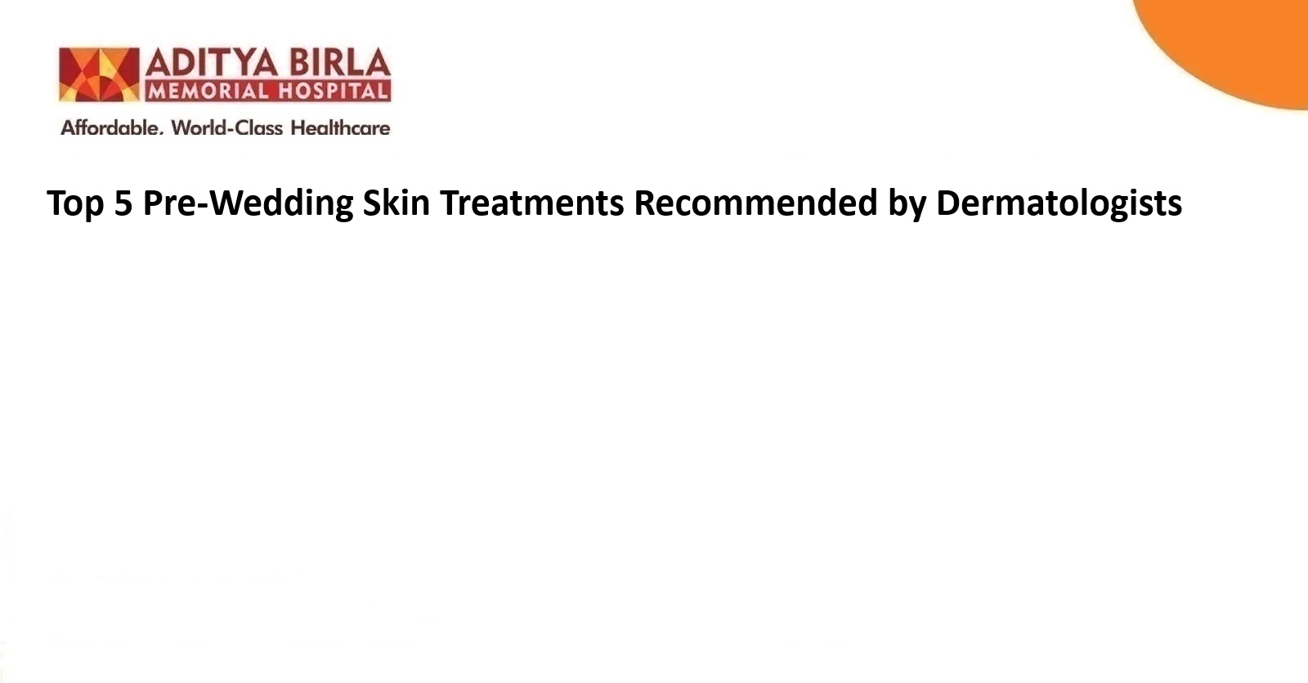
Dermatologist-recommended skin care for brides has evolved into a structured discipline that merges aesthetics with medical accuracy. Many patients seek dermatologist facial treatments in the months leading up to weddings.
Some prefer all-natural therapies, while others request evidence-based procedures. Pre-wedding skin treatments are no longer a cosmetic afterthought. They reflect a medical approach to skin preparation involving diagnosis, response tracking and precision protocols.
This blog explores the types of skin care treatments dermatologists most often recommend to prepare skin for weddings. The treatments listed here follow guidelines informed by both clinical dermatology and aesthetic practice. They include widely accepted pre-wedding skin treatments used by dermatologists in outpatient care. The treatments improve skin tone, reduce visible concerns and support confidence on the wedding day.
Why Pre-Bridal Skin Care Matters
The skin is the most visible interface in wedding photographs and ceremonial documentation. Any breakouts, texture irregularities or pigmentation may affect appearance during events. That is why dermatologist skin care planning focuses on both aesthetic and medical priorities. Skin conditions such as acne, melasma, enlarged pores, or scarring may not resolve quickly. Some patients may also experience stress-induced flare-ups, which require specialist support.
Pre-wedding skin treatments must begin early enough to allow skin adaptation. Depending on the concern, this may require weeks or months of care. A dermatologist will usually evaluate a patient's history, skin type, and event timeline. This ensures the treatment plan avoids post-procedure irritation, rebound pigmentation or sensitisation before the wedding.
Here are some common pre-wedding treatments dermatologists in Pimpri Chinchwad, Pune, or other cities may recommend:
1. Facial Rejuvenation
Facial rejuvenation involves a group of dermatologist-recommended skin care techniques that support healthier tone, better hydration and even texture. These include advanced facials, medi-facials, LED light therapies, and hydration-based protocols. A dermatologist specialising in skin care may recommend these for patients without major conditions who seek mild refinement.
Dermatologist facial treatments target dryness, dullness, fine lines and congestion. They stimulate microcirculation and exfoliate the upper layers of the skin. The result may be improved clarity and glow. Facial rejuvenation is usually done across 3 to 4 sessions spaced weeks apart. It is often combined with maintenance skin care treatments such as cleansing, sunscreen and barrier repair.
2. Chemical Peels and Pigmentation Treatments
Dermatologists often recommend chemical peels as targeted skin care treatments. The process is effective for surface-level pigmentation, tanning, acne-related marks or uneven skin tone. These treatments use a peeling solution applied under clinical supervision to exfoliate the outermost skin layers and trigger regeneration beneath the surface.
Pre-wedding skin treatments such as these may be suitable for managing post-inflammatory hyperpigmentation or chronic melasma, depending on the depth and skin reactivity. The frequency and duration of sessions depend entirely on the dermatologist's evaluation and the individual patient's response over time.
Supportive skin care during peel recovery often includes gentle moisturisers, broad-spectrum sun protection and barrier-restoring formulations that prevent irritation. In some instances, pigmentation treatment may also involve energy-based systems or light masks. A dermatologist in Pimpri Chinchwad may schedule peels well in advance of the wedding to avoid dryness, flaking or visible skin reaction.
3. Platelet-Rich Plasma (PRP) Therapy
Platelet-rich plasma therapy is a dermatologist-recommended skin care technique that uses autologous growth factors to support collagen production and refine skin quality over time. The process involves blood collection, centrifugation to isolate the enriched plasma, and reapplication into the dermis using medical-grade micro-needling tools or precision injections.
PRP may be advised for treating volume loss, surface texture issues, acne scars or laxity in the periorbital or midface region. It is often integrated into pre-wedding skin treatments when patients prefer biologically sourced options with a low risk of hypersensitivity.
Most treatment plans include multiple sessions conducted several weeks apart. Dermatologist skin care guidelines post-PRP usually include mild cleansers, anti-inflammatory topicals and physical sunblocks to prevent irritation or pigmentary change during healing. Results emerge progressively after each round of treatment.
4. Skin Resurfacing and Scar Reduction
For brides who have long-standing acne scars, trauma marks or texture irregularities, skin resurfacing may be advised. This refers to laser-based or energy-based techniques that remove damaged superficial skin and promote healing. Fractional laser and radiofrequency micro-needling are common tools for this purpose.

These dermatologist skin care treatments promote collagen remodelling, reduce scar depth, and even out surface texture. Since resurfacing has downtime, it is usually performed months before the wedding. The exact number of sessions depends on skin condition and healing time.
A dermatologist may also suggest scar-specific techniques, such as subcision or fillers, if scars are deep and tethered. Resurfacing must be paired with a strict post-care plan to avoid secondary pigmentation or barrier compromise.
5. Botox and Dermal Fillers
Injectables such as botulinum toxin and dermal fillers are dermatologist-recommended skin care treatments for contour correction and facial balancing. These procedures are elective and require expert knowledge of facial anatomy.
Botox is used to soften dynamic wrinkles caused by muscle movement, such as frown lines, crow’s feet, and forehead creases. Fillers help restore volume in areas like the under-eye, cheek, lips or chin. When used appropriately, they enhance proportions without altering natural identity.
These dermatologist facial treatments should be done weeks before the event to allow settling and reduce the risk of bruising. Results may last several months, depending on the product.
Choosing the Right Dermatologist and Your Pre-Wedding Skin Timeline
Bridal skin care must begin with a consultation with a trained dermatologist specialising in skin care. The dermatologist will assess your skin type, existing concerns and how much time is available before the wedding. Treatments such as resurfacing or injectables need longer timelines. Maintenance therapies may be introduced closer to the date.
A good pre-wedding skin treatment plan will involve a mix of therapeutic, preventive and enhancing procedures. It avoids last-minute treatments that may irritate. Patients are advised to follow all medical instructions during the process and not change products on their own.
Conclusion
Pre-wedding skin treatments combine medical dermatology with aesthetic insight. Whether addressing scars, pigment, dullness or fine lines, the treatment plan must begin early and be aligned with the wedding date.
A dermatologist-recommended skincare regimen offers both safety and results when planned appropriately. It involves clinical judgement, product supervision and evidence-informed procedures. The best outcomes occur when patients follow the full pathway (from diagnosis to post-treatment maintenance).
Frequently Asked Questions (FAQs)
1. What are the best treatments to prepare my skin before the wedding day?
Facial rejuvenation, chemical peels, PRP therapy, laser resurfacing and hydration therapies are recommended by dermatologists depending on the concern and skin type.
2. How far in advance should I start my pre-wedding skin treatment plan?
Start at least three months before the wedding. Some treatments, such as lasers or fillers, may require more planning and multiple sessions for optimal results.
3. Are chemical peels safe for all skin types before a wedding?
Chemical peels may be used on different skin types, but require a dermatologist’s supervision. The type of peel and timing must match your skin’s sensitivity and recovery pace.
4. What should I ask a dermatologist when planning my pre-wedding skin treatments?
When you visit the best dermatology hospital in Pimpri-Chinchwad, Pune, or any other city, ask about recommended procedures for your skin type, the number of required sessions, downtime, risks, and what to avoid. Also, confirm when to stop treatments before the wedding.
5. How important is the homecare routine (cleansing, moisturiser, SPF) alongside professional treatments?
Home care supports results, prevents post-treatment complications and maintains barrier health. A basic routine including a cleanser, a non-irritant moisturiser, and sunscreen is essential during the treatment phase.

